Michael E. Cohen Residents Research Day

State University of New York at Buffalo,
Department of Neurology,
School of Medicine and Biomedical
Sciences
2015

Friday, June 12th, 2015

11:00 am—4:00 pm

Cummings Conference Center

Graduating Residents

Nour Abdelhamid, MBBCh
Adult Neurology, Chief Res.

Ghasan Ahmad, MBBS Adult Neurology

Deeya Gaindh, MD Adult Neurology

Muhammad Masud, MBBS Adult Neurology

Karanbir Singh, MBBS Adult Neurology

Naeem Mahfooz, MBBS Child Neurology, PGY5

Pooja Sofat, MBBS

Adult Neurology, Chief Resident

PGY III Residents 2014 - 2015

Mahmoud Abdelrazek, MBBCh

Farid Din, MBBS

Adult Neurology, PGY3

Child Neurology, PGY4

Adnan Khan, MBBS Adult Neurology, PGY3

Ghulam Mustafa, MBBS PGY3-Adult Neurology

Haris Kamal, MD
Adult Neurology, PGY3

Incoming Chief Resident

Aurangzeb Memon, MBBS PGY3—Adult Neurology Incoming Chief Resident

Lindsay Dudeck, MD; PGY3; Child

PGY II Residents 2014—2015

Ashish Arora, MBBS PGY2—Adult Neurology

Hao Cheng, MD

PGY2—Adult Neurology

Rabia Ghazi, MBBS PGY2-Adult Neurology

Svetlana Primma, MD PGY 2—Adult Neurology

Brian Trummer, MD, PhD.,
PGY2-Adult Neurology

State University of New York at Buffalo,
Department of Neurology,

School of Medicine and Biomedical Sciences

2

Welcome/Introduction

11:00 am | Gil I. Wolfe, M.D., FAAN
 | Robert Zivadinov, MD, PhD
 | Nicholas J. Silvestri, M.D.
Presentation Session # 1
11:10 am | Nour Abdelhamid, MBBCh
11:30 am | Ghasan Ahmad, MBBS
11:50 am | Deeya Gaindh, MD
12:10 pm | Naeem Mahfooz, MBBS
12:30 pm | Break/Lunch
Presentation Session # 2
1:00 pm | Muhammad Masud, MBBS
1:20 pm | Karanbir Singh, MBBS
1:40 pm | Pooja Sofat, MBBS
2:00 pm | Mahmoud Abdelrazek, MBBCh
2:20 pm | Break/Photo Session
Presentation Session # 3
2:30 pm | Farid Din, MBBS
2:50 pm | Haris Kamal, MD
3:10 pm | Adnan Khan, MBBS
3:30 pm | Aurangzeb Memon, MBBS
3:45 pm | Ghulam Mustafa, MBBS

3

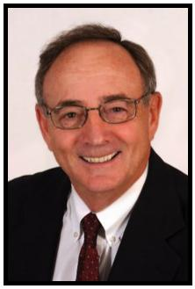
Michael Cohen, MD, Profes-sor of Neurology and Pediat-rics, State University of New York at Buffalo

Research day in the Department of Neurology is always auspicious, for the residents and faculty alike. It is a time to reflect on the years spent at this University and the influence that your peers and the fac-ulty have had on your development as sophisticated physicians.

Each year at this time, it is imperative to reflect on how the 3-4 years of training has changed the individual from an insecure physician to one who has become confident and expert in their chosen field.

Every year since 1984, the senior residents have been asked to pre-sent a research paper to the faculty, representing either clinical or basic research. With each passing year, the quality of the presenta-tions has improved. Faculty and residents alike increasingly have recognized the value of this activity. Not surprising, many of the pa-pers have resulted in publication in well-regarded, peer-reviewed neurology journals.

As the seniors move on, we will miss their presence and contributions to the life of the department. Hopefully, you carry with you memories not only of the good, the bad and the ugly but also an appreciation of how these years have challenged you, changed you and contrib-uted to your intellectual growth. Your performance today attests to this statement. Good luck. Do not forget us and stay in touch.

Michael E. Cohen, MD, FAAN, FANA, is a Professor of Pediatrics and Neurolo-gy. Dr. Cohen was chair of the UB Neurology Department from 1983-2000. He is a past President of the Child Neurology Society, The Association of Child neurology Professors and past President of the Section of Child Neurology of the American Academy of Neurology. He has been responsible for several of the all-day child neurology courses given at the annual meeting of the academy. He was a member of the organizing committee of the ABPN for neurodevelopmental neurology and has served on the writing committee for recertification for child neurology of the ABPN. His research interests have been primarily in neuro-oncology.

4

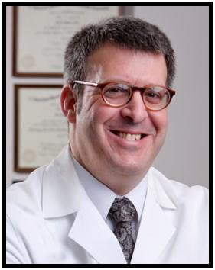
Gil I. Wolfe, M.D., FAAN
Chief, Jacobs Neurological
Institute Chair, Department of

Neurology
SUNY at Buffalo School of
Medicine
and Biomedical Sciences

Welcome to the Michael E. Cohen, M.D., Resident Research Day; the annual event held by the University at Buffalo’s Department of Neurology staged in recognition of research projects conduct-ed by our residents and fellows.

Our research day represents the culmination of months and even years of meticulous work by our neurology trainees. This work is now subjected to peer scrutiny and competition for awards.

Moreover, the research day recognizes the involvement of our faculty and fellows in the mentorship of residents. Experience and lessons learned are passed from each generation of physi-cian researchers to the next in just this way.

Through the years, graduates of our program have repeatedly confirmed the invaluable experience of their participation in the Research Day. Their comments express an increased apprecia-tion not only for the clinical research process itself but also for the positive impact it will always have on their clinical careers.

Today's presentations continue an established tradition of aca-demic excellence. Please join the entire UB Department of Neu-rology in commending each resident and fellow for the innova-tion, scope and execution of their projects. On display are ana-lytical skills, judgment and integrity. Please also accept my sin-cere appreciation to all of you for contributing to and sharing the day's events.

Best wishes to all of you!

Dr. Wolfe

5

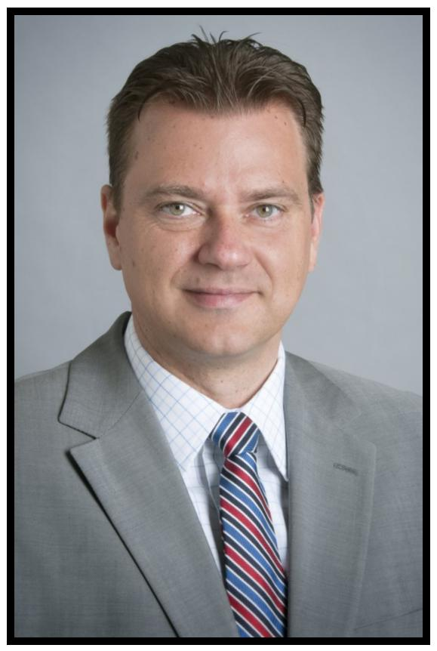
Robert Zivadinov, M.D., Ph.D., FAAN
Resident Research Training Program
Director

Professor of Neurology,
Department of Neurology
SUNY at Buffalo School of Medicine
and Biomedical Sciences;
BNAC Director;
MRI Imaging Director at The CTRC

This is the twelfth year of our expanded Resident Research Training Pro-gram and the scope as well as range of the projects presented today undoubtedly display resourcefulness, determination, commitment and knowledge.

Whether our presenters’ vocation leads them towards clinical work or further research, they are all true intellectuals, having shown the judg-ment, perception and motivation that will guide them proficiently in years to come. I commend each and every one of them for a job well done.

It has been my primary purpose in these last few years to promote as well as facilitate such a development in project diversity. As you see in our program today, although we continue to encourage study in the fields of our core and strength areas—multiple sclerosis and stroke—we have also increased the number of projects that explore other neurological disorders and diseases.

With these additional advancements, we hope to “pave the way” to the next level of research distinction. Projects that are progressively far-reaching and innovative will considerably advance the careers of our new physicians as well as enhance both the importance and notoriety of our Neurology Residency Program. What an amazing endeavor to be a part of!

6

Nicholas J. Silvestri, M.D.,

Assistant Professor of

Clinical Neurology

Program Director,

Adult Neurology Residency,

State University of New York at

Buffalo & School of Biomedical

Sciences

It gives me great pleasure to see another class of resi-dents graduate from our training program. Over the past three years, we have watched these individuals grow into outstanding clinicians and scientists. I am certain that they will make us proud. As the end of another academ-ic year approaches, I am inspired by the enthusiasm and

fortitude of our trainees and am committed to making

this program one of the best around. I would like to thank all of our residents for their hard work and dedication. I would also like to thank the faculty for their devotion to teaching and their support of the training program. Final-ly, I would like to acknowledge the outstanding efforts of Ms. Eva Tamoga and Mr. Caleb Clark, who work tirelessly in support of the program.

A native of Kenmore, New York, Dr. Silvestri earned his MD from SUNY at Buffalo School of Medicine before completing his internship in inter-nal medicine, residency in neurology and fellowship in neuromuscular medicine at Harvard Medical School/Beth Israel Deaconess Medical Center in Boston, Massachusetts. He joined the faculty in the Depart-ment of Neurology at SUNY Buffalo School of Medicine in 2009 and has served as Program Director of the Adult Neurology Residency since 2011. Dr. Silvestri is a member of the University at Buffalo Gradu-ate Medical Education Committee and the Program Director Advisory Committee. He is also the chair of the education committee of the Myasthenia Gravis Foundation of America.

7

“Clinical evaluation of the potential stroke pa-tient by neurology residents prior to MRI”

Nour Abdelhamid, MBBCh Sandhya Mehla, MBBS; Sal-man Farooq, MBBS; Katelyn Kavak, MSc; Annemarie
Crumlish, Marilou Ching, MD, MPH

State University of New York at Buffalo; School of Medicine and Biomedical Sciences, Department of Neurology
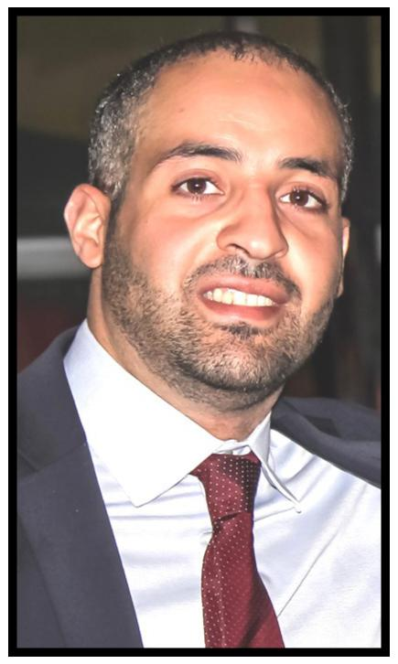

Nour attended medical school in Cairo, Egypt. After graduation, he did one year of a transitional internship and commenced Neuropsychiatry residency training. Soon after, he decided to move to Toronto, Cana-da. In Toronto, Nour worked in the area of clinical research for novel drugs with multiple pharmaceutical companies. He also joined the re-search team in the department of Psychiatry at the University of Toronto. Subsequently, he moved to Buffalo where he completed his internship and neurology residency, In addition to being the chief resident for the current year. Nour has special interests in the areas of vascular neurolo-gy and neuro-critical care. He will be joining the neurology department at the University of Texas at Houston as a faculty member as well as a vascular neurology fellow.

8

Background. MRI has emerged as the gold standard for confirming the diagnosis of acute ischemic stroke (AIS). This resulted in an in-crease in the number of MRIs ordered which in turn may influence neurology residents to rely on imaging at the expense of their clinical skills.

Objectives. 1) To assess the clinical acumen of residents in the initial evaluation of the potential stroke patient. 2) To investigate different variables in the patient’s clinical picture that influenced the clinical diagnosis of residents and to determine if these variables are predic-tive of MRI findings.

Methods. The study period was from September, 2014 to May, 2015. Neurology residents at SUNY Buffalo were requested

to complete online questionnaires for potential stroke patients wherein a brain MRI was ordered. The questionnaire included preliminary clini-cal diagnoses made by the resident (stroke yes or no) and on what basis was the diagnosis made. MRI reports were later reviewed and compared to the resident’s clinical diagnosis. The chi-square test was used in data analysis.

Results. A total of 231 brain MRIs were ordered. Resident’s clinical di-agnosis was correct in 191 patients (accuracy = 83%, p <0.001). Accu-racy per PGY level was calculated to be 80%, 79% and 93% for PGY2,

3 and 4 respectively (p< 0.001). Embolic risk factors and cortical stroke signs were the variables used by residents which correctly had the highest association with positive MRI finding, 85%. Functional patients and history of seizure disorder were variables used by residents which correctly had the highest association with negative MRI results, 100 and 89% respectively. The residents’ clinical evaluation was incorrect in 26% of patients with a history of previous stroke.

Conclusion. Neurology residents at our institution are accurate in their initial clinical assessment of potential stroke patients prior to MRI great-er than 80% of the time. PGY4s performed better, while PGY2 and 3 performed at the same level which needs to be studied further. Varia-bles in a clinical picture such as functional symptoms and history of seizure were most helpful to our residents. Patients with a history of previous stroke were the most challenging for our residents to evalu-ate.

IRB approval. Sep 12th, 2014
Disclosure. Nothing to disclose from all authors.

Conflict of interest. No conflict of interests from any of the authors.

9

“Factors influencing delay in epilepsy Surgery; A retrospective data review.”

State University of New York at Buffalo;

School of Medicine and Biomedical Sciences,
Department of Neurology

Ghasan Ahmad, MBBS1; Naveed Chaudhry2, MS;

Katelyn Kavak1, MSc; Ping Li, MD1.
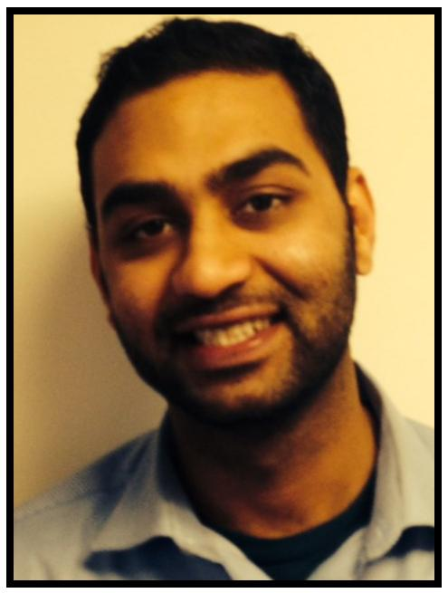

Dr. Ahmad earned his medical degree from King Edward Medical Univer-sity Pakistan after which he continued to do a year of internship at Mayo Hospital Lahore. After the internship, Dr. Ahmad joined The University at Buffalo and completed training in Internal Medicine to pursue training in Neurology. Currently, Dr. Ahmad is in his fourth year of neurology training. Dr. Ahmad’s primary research interest lies in cerebrovascular diseases and epilepsy. He has excellent bedside manners and is a member of the gold humanism honor society.

10

Introduction: Medically intractable focal epilepsy affects a third of patients with seizures which are potentially surgically remediable. Several factors have been suggested for the reasons of the delays in epilepsy surgery. Nationally, the average time to surgery after onset of seizures is 20 years.

Objectives: The objective of this study was to analyze the charac-teristics of the population of patients in Western New York who un-derwent surgery for refractory epilepsy, the time duration between onset of epilepsy and surgery and the factors influencing the time duration.

Methods: A retrospective chart review of 49 patients was per-formed on the patients diagnosed with refractory epilepsy from 2003-2014 who underwent surgery at our center. Demographic data such as age, gender, ethnicity, insurance information, seizure severity, number of medications, EEG results, MRI lesions and time to surgery were collected. A logistic regression model was used for analysis with a p value set at 0.05.

Results: Mean waiting time to surgery at our center (13.5 vs 20 years) was shorter compared to the other centers in The United States. 81% (37) of the patients were diagnosed with lesions on MRI which included tumors 13% (6). Mean time of patients with a lesion was 13.4 years vs 15.5 years for patients without a lesion. Mean time for pediatric patients was 4.5 years and for an adult patient was 21 years. When a multivariate regression model was applied, a shorter time to surgery was associated with pediatric patients with a p value of 0.02 (R 0.534, 95% CI 5.24-20.4).

Conclusion: Our study suggests that pediatric patients underwent surgeries earlier compared to the adult population, which may be due to earlier identification by the local pediatric neurologists. Fur-ther research with a bigger sample set is needed to probe the fac-tors influencing the time duration between onset of epilepsy and surgery.

Conflicts of Interests/Disclosures: None from any of the authors.

IRB approved by SUNY Buffalo.

11

“Cancer, family history and Multiple Sclerosis.”

Deeya Gaindh, MD; Katelyn Kavak, MSc, ,2, MS; Barbara Teter1,2,3, PhD; Diane Cookfair PhD; Bianca Weinstock-Guttman1,2,3, MD

- Jacobs Comprehensive MS Treatment and Research Center,

University at Buffalo, Buffalo, NY, USA;

- New York State MS Consortium, University at Buffalo, Buffalo, NY, USA 3 Department of Neurology, State University of New York

at Buffalo, Buffalo, NY
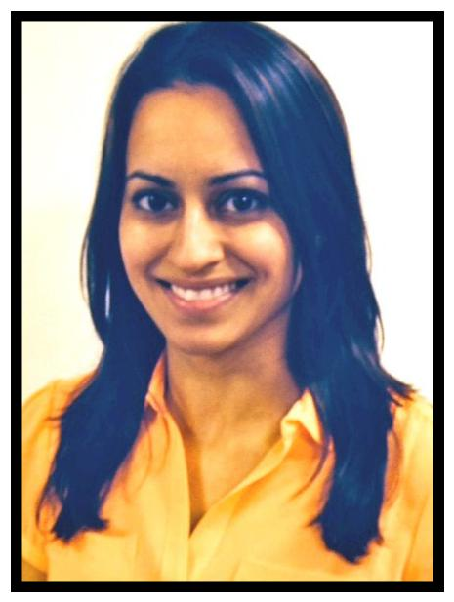

Deeya spent the majority of her childhood in Maine, where her family still resides. She completed her undergraduate education at Bowdoin College in Brunswick, Maine as a Sarah and James Bowdoin Scholar. After college, Deeya spent one year at the Na-

tional Institutes of Health (NIH) in Bethesda, Maryland investigating

disease modifying therapies in Multiple Sclerosis using neuro-imaging. She graduated from Saint George's University School of Medicine and lived in Grenada and New York City. Dr. Gaindh is currently a PGY-4 adult neurology resident at The University of Buf-falo. She is looking forward to moving back to New York City after graduation for a neuro-oncology fellowship at Memorial Sloan Ket-tering Cancer Center.

12

Background: Studies examining the association between can-cer risk, multiple sclerosis (MS) and disease modifying therapy (DMT), have shown conflicting results. Understanding the link between cancer, MS and family history may give insights into th e immune factors in developing MS.

Objective: Assess the prevalence of cancer in MS patients and evaluate if DMT users were more likely to report cancer. Family history of cancer in first degree relatives of MS patients and prev-alence of cancer in patients with a family history of cancer was also assessed.

Methods: Subjects were part of the New York State Multiple Sclerosis Consortium (NYSMSC) registry. Cancer prevalence and DMT use was determined at study enrollment. Independent sam-ples t-tests and chi-square tests were utilized to determine if there were any differences between MS patients who reported cancer compared to those who did not. A binomial test was used to determine if cancer prevalence in NYSMSC was signifi-cantly different from New York State (NYS) cancer prevalence as reported by the National Cancer Institute (NCI). The prevalence of MS patients with a history of cancer reporting a family history of cancer was also calculated.

Results: Prevalence of cancer in males and females in the NYSMSC cohort was lower than cancer prevalence reported for NYS (p<0.001). Patients with cancer were older at MS diagnosis and more likely to be female (p<0.001). MS patients with a histo-ry of cancer were more likely to report DMT use (p<0.001). MS patients with a history of cancer were more likely to report hav-ing a family history of cancer (p<.001).

Conclusions: Our results of lower cancer prevalence in NYSMSC compared to NYS concur with prior studies showing decreased cancer prevalence in MS patients. Patients with a history of can-cer were more likely to report DMT use compared to patients with no history of cancer, warranting further studies into long term use of DMTs.

Report disclosures: Dr. Deeya Gaindh, Dr. Barbara Teter and Katelyn Kavak:

None.

Dr. Bianca Weinstock-Guttman: Dr. Bianca Weinstock-Guttman has participated in speaker’s bureaus and served as a consultant for Biogen Idec, Teva Neurosci-ences, EMD Serono, Pfizer, Novartis, Genzyme, and Acorda. She also has re-ceived grant/research support from the agencies listed above as well as ITN, Questcor and Shire. No other industry financial relationships or conflicts of interest exist.

13

“Optimal duration of continuous video-

electroencephalography in term infants with hypoxic-ischemic encephalopathy treated with induced hy-pothermia.”

Naeem Mahfooz, Arie Weinstock, David Vargas Lowy, Sa-rah G Finnegan, Satyan Lakshminrusimha.

State University of New York at Buffalo;

School of Medicine and Biomedical Sciences,
Department of Neurology
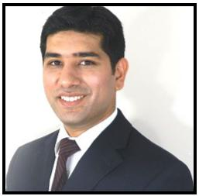

Dr. Mahfooz graduated from King Edward Medical College, in Pakistan in 2006. He worked as a research assistant at the Women and Children’s Hospi-tal of Buffalo and the Jacobs Neurological Institute in Buffalo, New York. He did his pediatric internship and residency at the State University of New York at Buffalo where he graduated in 2012. His areas of interests include multiple sclerosis, myelination patterns, pediatric epilepsy and epilepsy surgery. Dr. Mahfooz has several scientific contributions which include 5 manuscripts, 9 posters and 2 case reports. He is on the editorial review board of 4 medical journals. Naeem is presently a part of several research projects. He is a member of the American Academy of Neurology, the American Academy of Pediatrics and the American Medical Association. Dr. Mahfooz is gradu-ating this month from his pediatric neurology residency program from the State University of New York at Buffalo. He will be joining the Cleveland Clin-ic in Cleveland, Ohio for his fellowship in pediatric epilepsy starting July 1, 2015.

14

Introduction:

Induced therapeutic hypothermia has shown to reduce the mortality and disability in term neonates with hypoxic-ischemic encephalopathy (HIE). The neuroprotective role of therapeutic hypothermia has been supported by two recent meta-analyses (Tagin et al 2012, Jacobs et al. 2013), indicating improvement in survival and developmental out-come in infants with moderate to severe HIE. Continuous Video-Electroencephalography (CVEEG) has been used to evaluate seizure and its correlation with outcome. Murray et al reported in 2009 that early EEG was a reliable study to pre-dict neurodevelopmental outcome in HIE. EEG abnormalities improved or remained stable at 6, 12, 24, and 48 hours, with the best predictive value observed at 6 hours of life. It is not known whether CVEEG should be performed for the whole duration of hypo-thermia (72 hours) or for shorter durations. IRB approval was obtained from SUNY Buffalo.

Purpose:

The purpose of this study was to evaluate whether initial baseline EEG and follow up 24 hours CVEEG studies can predict seizure recurrence in the next 48 hours CVEEG, in neo-nates with HIE treated with hypothermia.

Methods:

This was a retrospective study and was approved by the Children and Youth IRB. The following clinical data were collected: gestational age, birth weight, gender, Apgar score, Sarnat score, and presence of clinical seizures. The following EEG data were rec-orded: normal background, excessive discontinuity, background suppression, burst sup-pression, sharp waves, excessive low voltage, and presence of EEG seizure. Data were collected form 35 neonates with gestational age between 34-41 weeks with HIE treated with whole-body induced hypothermia. Neonates were followed at WCHOB between May 2010 to May 2014. EEG reports were collected from initial EEG, and CVEEG at 24, 48 and 72 hours. Baseline EEG and 24 hour CVEEG was compared with CVEEG data at 48 and 72 hours. The results were statistically analyzed in SAS 9.3 using the McNemar’s test.

Results:

Of the 35 patients who had whole body induced cooling for HIE, 9 patients (25.7%; 6 males and 3 females) had seizures with EEG ictal changes within 72 hours. Time of sei-zure onset was within 30 minutes of initial EEG in 6 patients (17%), within 24hr in 2 patients (6%), and during rewarming on day 3 in one patient (3%). No seizure occurrence was documented on day 2. Two additional neonates had clinical spells starting in the first 24 hours that were suspicious for seizures but without EEG correlation. There was a signifi-cant decrease in the frequency of seizures by 48 hours after the initiation of antiepilep-tic drugs (p= 0.04, McNemar’s test) in comparison to EEG taken at 24-hour period. There was also a significant reduction in background suppression in 48 hours when compared with 24 hours (p= 0.02, McNemar’s test). There was no new incidence of background suppression in 48 and 72 hours. Among the different time points no significant change was observed in excessive discontinuity, burst suppression, sharp wave and excessive low voltage. 90 % of patients presenting with seizures within 72 hours of birth had initial Sarnat staging of moderate to severe HIE.

Conclusion:

Our study suggest that CVEEG for cooling has high diagnostic yield within the first 24 hours and during the rewarming phase on day 3. All neonates with seizures presented within 24 hours, except one that occurred during the rewarming phase.

As CVEEG is an expensive procedure, medical resources could be spared by perform-ing CVEEG on first 24 hours and on day 3 during rewarming unless EEG reveals seizures within the first 24 hours. For neonates with proven seizures within the first 24 hours, CVEEG should be continued for the whole 72 hours cooling protocol. No conflicts of interest exists and the authors have nothing to disclose.

15

“Natural outcomes of strokes from proximal intra-cranial vessel occlusion and NIHSS less than 8.”

Muhammad W. Masud 3,4, Ghasan Ahmad 3,4 and Elad Levy 1,2,5,6

1Department of Neurosurgery, University at Buffalo, State University of New York, Buffalo, New York, USA 2Department of Neurosurgery, Gates Vascular Institute, Kaleida Health, Buffalo, New York, USA 3Department of Neurology, University at Buffalo, State University of New York, Buffalo, New York, USA 4Department of Neurology, Gates Vascular Institute, Kaleida Health, Buffalo, New York, USA 5Department of Radiology, University at Buffalo, State University of New York, Buffalo, New York, USA 6Toshiba Stroke and Research Vascular Center, University at Buffa-lo, State University of New York, Buffalo, New York, USA
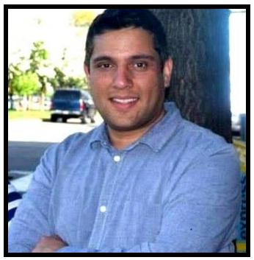

Dr. Masud earned his medical degree from King Edward Medical Universi-ty Lahore, Pakistan. After graduation, he spent one year doing basic sci-ence research at Johns Hopkins University and then moved to buffalo to work with the MS research team at The Jacobs Neurologic Institute. He has authored and co-authored multiple research papers. He completed one year of internal medicine at UB and continued his training in Neurology. His research interests include Multiple Sclerosis and cerebrovascular dis-eases and has published in both disciplines. He will assume a faculty posi-tion at The University of Tennessee, Knoxville after graduation.

16

OBJECTIVE:

Acute ischemic stroke due to proximal intracranial vessel occlusion is asso-ciated with poor prognosis and neurologic outcomes. Outcomes specifi-cally in patients with stroke due to these occlusions and lower National Institutes of Health Stroke Scale (NIHSS) scores (0-7 range) have not been described previously.

METHODS:

We retrospectively reviewed discharge outcomes (reported in our 'Get With the Guidelines-Stroke' database) in patients with an admission NIHSS score of 0-7 due to proximal intracranial large vessel occlusion (based on CT angiography results) who were excluded from receiving intravenous (IV) thrombolysis with recombinant tissue plasminogen activator and endovascular intra-arterial (IA) stroke interventions.

RESULTS:

Among the 204 patients included in our analysis, younger age and lower admission NIHSS score (0-4 range) were strong predictors of good out-come (defined as ability to ambulate independently) at discharge whereas female sex was a predictor of poor outcome. There was no sig-nificant difference between cerebrovascular risk factors, specific sites of occlusion, or presenting symptoms and outcomes at discharge. There was great variability in functional outcomes at discharge and discharge dispo-sition (home versus acute or subacute facility or nursing home versus death/hospice) with a trend toward worse outcomes in patients with higher (5-7 range) NIHSS scores on admission.

CONCLUSIONS:

Patients with acute stroke due to large vessel occlusion and low admission NIHSS scores (0-7 range) may have poor functional outcomes at dis-charge. These patients, if not eligible for IV thrombolysis, might benefit from IA revascularization therapies.

Disclosures: Muhammad Masud: None. Ghasan Ahmad: None, Elad Levy: Re-
search grant support, other research support (devices), and honoraria: Boston Sci-

entific; research support: Codman and ev3/Covidien Vascular Therapies; owner-ship interests: Intratech Medical and Mynx/Access Closure; consultant: Codman, ev3/Covidien Vascular Therapies, and TheraSyn Sensors; fees for carotid stent train-ing: Abbott Vascular and ev3/ Covidien Vascular Therapies. IRB was approved at SUNY Buffalo. No conflicts of interests exists.

17

“Safety of Intravenous Thrombolysis for acute Ischemic Stroke in patients with pre-existing Intracranial Neoplasms or Cerebral Aneu-rysms.”

Department of Neurology; Stroke,
The State University of New York at Buffalo New
York at Buffalo, USA

Karanbir Singh, MBBS1; Ashkan Mowla, MD1; Sandhya Mehla, MBBS1; Mohammad K. Ahmed, MBBS1; Peyman Shirani, MD1; Robert N. Sawyer, MD1; Annemarie Crumlish, CCRC1; Marilou Ching, MD, MPH, FACP1
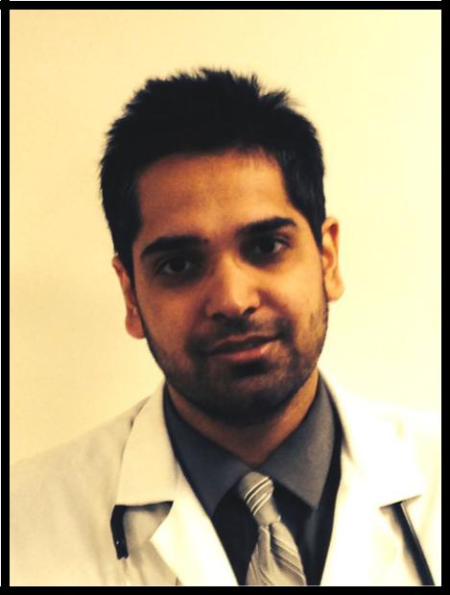

Karan was born and raised in India. He went to medical school at The Government Medical College, Amritsar, India. Upon completion of medical school, he matched into a Neurology residency at SUNY Buffalo. He met his wife during his Internal Medicine year, has been happily married and has a 7-month-old son. During residency, he has been actively involved in research and has published in areas of Stroke, Neuroimaging and Neuro-Oncology. He is starting a fellow-ship in Neuroimaging at The DENT. After his fellowship, he plans to practice as a Neurologist and Neuroimager in India.

18

Introduction:

Intracranial neoplasms and cerebral aneurysms are currently considered a contraindication for intravenous (IV) thrombolysis in acute ischemic stroke, due to a hypothetical increase in bleeding risk. Minimal data is available on the safety of IV thrombolysis in these patients. We sought to determine the safety of IV rtPA in such patients through a retrospective study. IRB ap-proval was obtained through SUNY Buffalo.

Methods:

We reviewed the medical records and brain imaging of patients who re-ceived IV rtPA for acute ischemic stroke from January 2006 to April 2014 at our center. Subsets of patients with intracranial neoplasms or cerebral an-eurysms were identified. We looked into bleeding rate within the neoplasm or hemorrhage related to the aneurysm in these patients after IV rtPA ad-ministration.

Results:

637 patients received IV rtPA for acute ischemic stroke, 13 (2%) were found to have an intracranial neoplasm. Twelve had meningioma and 1 had an intracranial lipoma. The size of neoplasms ranged from 10 mm to 34 mm in maximum dimension. Among these 13 patients, 11 received only IV rtPA and 2 received IV rtPA followed by Intra-arterial (IA) thrombolysis. None of the 13 patients developed symptomatic intracranial hemorrhage (sICH) or hemorrhage into the tumor after thrombolysis.

Intracranial aneurysms were found in 33 (5.1%) patients; including 9 with multiple aneurysms (total of 44 aneurysms). 23 (70%) patients received only IV thrombolysis and 10 received a combination of IV and IA thrombolysis. The size of the largest aneurysm was 10 mm. No sICH occurred among the 23 patients receiving only IV thrombolysis. With a combination of IV and IA thrombolysis, 1 developed sICH in the location of infarct, distant to the an-eurysm.

Conclusion:

Our findings suggest that IV rtPA administration for acute ischemic stroke does not increase the risk of aneurysm rupture (up to 10mm in size) or hem-orrhage within benign neoplasms. Their listing as exclusion criteria for rtPA should be reconsidered to assure appropriate use of reperfusion therapy. Our study is the largest study on the safety of IV rtPA for acute ischemic stroke in patients with cerebral aneurysms and the first study for intracranial neoplasms.

Sources of Funding:

None.
Disclosure Statement:

Authors have no relevant financial interest to disclose.

19

“Time Interval Providing Highest Yield for Initial EEG in new onset Seizures”

Pooja Sofat, MBBS; Barbara Teeter, PhD, MPH; Katelyn S. Kavak, MSc; Rajesh Gupta MBBS, MD, MS; Ping Li, MD, MSc

Department of Neurology, State University of New York at Buffalo, School of Medicine and Biomedical Sciences; Buffalo, New York, USA
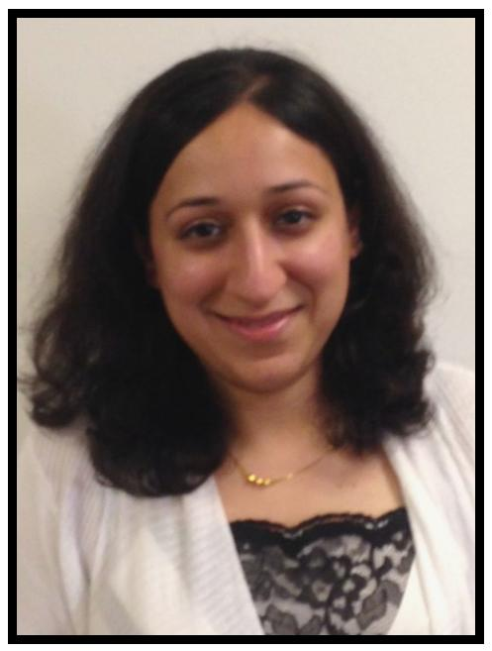

Dr. Pooja Sofat was born here in Buffalo. After choosing a career in medicine, she pursued her Medical Degree in Punjab at Daya-nand Medical College and Hospital. She completed her prelimi-nary year in Internal Medicine at Sisters of Charity Hospital in Buf-falo before joining our current Neurology program. She is a member of the Gold Humanism Honor Society and is currently completing her PGY-4 year. Dr. Sofat has served as chief Resi-dent of Neurology during the past academic year.

20

Introduction: The timing providing highest yield of initial EEG after new onset unprovoked seizures both in diagnosis and patient care is an im-portant and practical issue. Current guidelines suggest routine EEGs are standard of care in work-up of new onset unprovoked seizures. However, yield of the initial EEG and exact timeframe in which to per-form remain unclear. AAN 2007 practice parameter article quotes 48 hours to an average of 15 days; also suggests, in children, if done with-in 24 hours, is higher yield of abnormalities. Standardization for both adult and pediatric groups however is still lacking.

Objective: Determine concrete timeframe to perform initial EEG in new onset unprovoked seizures and provide a greater yield of EEG benefits in managing these patients.

Methods: Retrospective chart review study of both pediatric and adult patients identified from EEG Database from 1999-2014 located at WCHOB using keyword “new onset seizure”. Inclusion criteria: unpro-voked; age >=1 year; new onset.

Exclusion criteria: provoked; age <1; h/o stroke; known seizure history; status epilepticus, benign Rolandic epilepsy; abnormal CT/MRI brain. EEG reports were evaluated to determine presence or absence of epi-leptiform discharges. Demographic data such as age, gender, time (hours) from seizure onset to obtaining EEG and presence of epilepti-form discharges collected. Pearson correlation, student t-test, fisher exact tests and logistic regression model were used for data analysis. Significance was set at p<0.05.

Preliminary results: Among 59,181 records in EEG database, 899 were identified and 364 met inclusion criteria. For the EEG’s performed in the first 6 hours, 75% revealed presence of epileptiform discharges. For 6-12 hours, 50% had epileptiform discharges; 12-24 hours 30% demonstrated presence; 24-48 hours, 28 % presence; 48-72 hours revealed 24% pres-ence; 72-96 hours, 22% presence; and >96 hours group showed 26% presence. Negative correlation was noted between hours to obtain EEG and presence of epileptiform discharges with a p- value of 0.02.

Conclusion: Our results demonstrate statistical significance in yield of epileptiform discharges by performing EEG within first 6 hours of event, which can alter clinical practice and patient care.

Disclosures/Conflict of Interest: None

IRB approval 6/19/14

21

“Effect of Supine Position on outcome IN acute ischemic stroke “SUPINE””

Mahmoud Adelrazak, MBBCh, - PGY3, Christopher De-line,1MD, Marilou Ching, 1MD, Robert Sawyer,1MD, Ashkan Mowla,1MD

State University of New York at Buffalo;

School of Medicine and Biomedical Sciences,
Department of Neurology
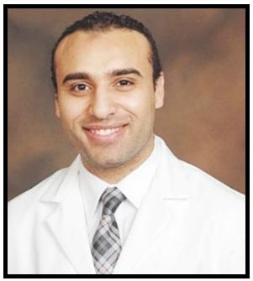

Dr. Mahmoud AbdelMageed AbdelRazek graduated from Ain Shams University in Cairo, Egypt in the top 2% of the class of 2011. He joined The SUNY Buffalo Neurology Residency program in June of 2012.
During his third year of residency, he became actively involved in several research projects. He is the first author of a retrospective study accepted for publication by "Cerebrovascular Diseases" jour-nal, entitled "Prior Asymptomatic Parenchymal Hemorrhage does not increase the risk of Intracranial Hemorrhage after Intravenous Throm-bolysis". He is also the first author of a review article entitled "Fibro-cartilagenous embolism: a comprehensive review of an under-studied cause of spinal cord infarction and proposed diagnostic cri-teria". He is currently piloting a randomized controlled trial that investi-gates the effect of body positioning during the acute phase

of ischemic strokes on neurological outcome. He plans on an aca-demic and clinical career dedicated towards research in the field of neurological sciences.

22

Background: The current American Heart Association (AHA) acute stroke management guidelines do not provide clear recommenda-tions on patient positioning during acute ischemic strokes. A direct re-lation between patient positioning during the acute phase of an is-chemic stroke and subsequent neurologic outcome has never been studied in a randomized controlled trial.

Objectives/Hypothesis: Our hypothesis is that implementing a rigid and active protocol to maintain a flat body position with the head of bed at zero degrees during the acute phase of ischemic strokes will improve neurologic outcome.

Methods: Eligible individuals are patients that are 18 years of age or older presenting with an ischemic stroke with a pre-stroke modified Rankin Score (mRS) of zero or 1 and with a clearly defined time of on-set or last known normal within 8 hours of randomization. Patients with any reason to prevent adherence to a flat body position will be ex-cluded. Enrolled subjects will be randomized to a study versus control arm. Patients in the study arm, in addition to receiving the standard of care, will be subjected to methods to actively implement a regimen of flat body positioning with head of bed at zero degrees for a period of 24 hours. Patients in the control arm will be kept at >30 degrees, but will be allowed to lay flat as routinely necessary for tests and other re-quirements.

A favorable outcome will be defined as a modified Rankin Score (mRS) of 0-1 at 60 days or improvement of the NIHSS by 5 or more points at 24 hrs after the start of the intervention.

Expected Results: We expect that a greater percentage of patients in the study arm will have a favorable outcome when compared to the control arm. This will provide Level B evidence to actively implement a regimen of flat body positioning during the acute phase of ischemic strokes.

IRB/IACUC APPROVAL

Package sent and awaiting approval.

Disclosures: Dr. Askhan Mowla is a promotional speaker for

Janssen Pharmaceutical, Inc. All other investigators report no disclo-sures.

Grant Funding: Nil

Conflicts of Interest: None reported by all authors.

23

“Pediatric Stroke among Western New
York Subjects.”

Principle Investigator: Farid Din, MBBS Co-Investigators: Drs. Osman Farooq and Thom-as Langan

State University of New York at Buffalo;
School of Medicine and Biomedical Sciences,

Department of Neurology

Farid Ud Din graduated from AIMC Pakistan, com-pleted residency in 2008 and worked in Oman until May of 2011. He started his residency at UB in 2011 and now is doing his Pediatric Neurology training.
His biggest achievement is an Award of best physi-

cian in last 25 years given by The Ministry of Health Oman.

Dr. Din likes to spend time with family as well as to cook and play cricket.

24

Background

Stroke and cerebral ischemia have been increasingly rec-ognized in children in recent years, but diagnosis and man-agement can be difficult because of the diversity of under-lying risk factors. Cerebrovascular disorders occur relatively often among children and adolescents, and stroke in chil-dren is now a common topic in the literature. Nevertheless, the incidence of stroke among children is low enough that it is difficult to plan clinical trials designed to improve thera-
py. Children and adolescents with stroke have remarkable

differences in presentation compared with older patients. Stroke type also varies according to age. As such, there is a paucity of information on cerebrovascular injury in the pediatric population.

Objectives:

Our goal is to describe clinical presentation patterns and potential predisposing factors to stroke and cerebral hy-poxic ischemic injury in the pediatric population.

Methods:

We will perform a retrospective review of charts of all pa-tients who present to the Women & Children’s Hospital of Buffalo with evidence or clinical suspicion of a stroke. We will enroll patients between January 2000 to January 2013. We will review their clinical histories, neuroimaging, labora-tory results and look at patterns of illness that may have predisposed these patients to their cerebrovascular injury.

Expected Results:

Our goal is to describe predisposing factors as well as clini-

cal descriptions and treatment of stroke in the pediatric

population of Western New York. We will compare our re-sults with that found in the medical literature.

IRB Approval:

Pending

COI & Disclosures: None of the authors have anything to declare in relation to this project.

25

“Rate, clinical features, safety profile and outcome of Intravenous Thrombolysis for Acute Ischemic Stroke in Patients with negative brain imaging.”

Haris Kamal, MD; Ashkan Mowla, MD*; Sandhya Mehla, MBBS, Peyman Shirani, MD; Karanbir Singh, MBBS; Salman Farooq, MBBS, Annmarie Crumlish, CCRC; Marilou Ching, MD, MPH; Robert Sawyer, MD

State University of New York at Buffalo;

School of Medicine and Biomedical Sciences, Department of Neurology—Stroke Buffalo, New York, USA
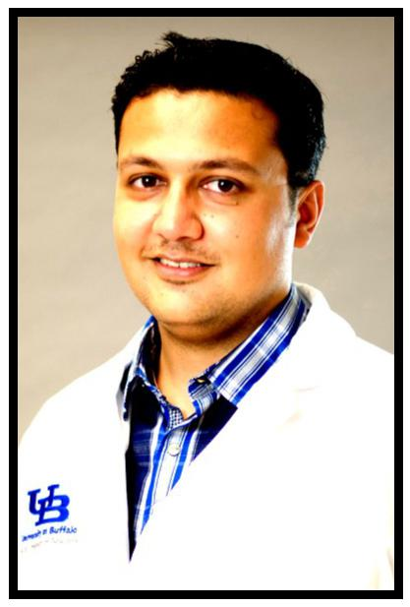

Dr. Haris Kamal is originally from India and grew up in Dubai, UAE during his schooling years. He completed medical school at Yerevan State Medical University, Armenia in 2009 with honors. Subsequently, he completed a year of rotating medical internship at a state hospital in New Delhi, India. Dr. Kamal joined the UB Neurology residency program after completing his medical internship at UB Internal Medicine in 2013.

Haris enjoys doing clinical research and has authored multiple papers in peer-reviewed journals. He has presented more than 18 research posters at National Conferences during the course of his residency including win-ning the award for best poster at HSS 2014, NY.

Dr. Kamal is a member of the Gold Humanism Honor Society and an in-coming Chief Resident. He is also a member of The Resident Leadership Advisory Committee at Kaleida Health. His research project today was accepted for a platform presentation at the International Stroke Confer-ence in February 2015 and was listed as one of the top projects.

26

INTRODUCTION:

The exigent time demand for intravenous (IV) r-tPA administration in acute ischemic stroke (AIS) may not give the necessary time for thorough evalu-ation in patients presenting with AIS symptoms. As a result, IV thrombolysis of transient ischemic attack (TIA) or conditions mimicking stroke but with a subsequent different diagnosis might occur. In addition, IV r-tPA may suffi-ciently resolve ischemia such that subsequent brain diffusion weighted MR imaging (DWI-MRI) is negative in some patients. It would be expected that brain CT scan and the more sensitive DWI-MRI would be negative in all these cases. We sought to determine the rate, clinical characteristics, safety profile and outcome of brain imaging-negative patients treated with IV r-tPA for AIS in our large volume stroke center.

METHODS:

We retrospectively reviewed the medical records and brain imaging of patients who received IV rtPA for AIS within 4.5 hours of symptom onset from January 2006 to April 2014 at our center. A subset of patients with absence of acute infarct/ischemia on their follow- up brain imaging were identified. We recorded age, admission NIH stroke scale (NIHSS), discharge NIHSS, discharge modified Rankin Score (mRS), symptom onset to treat-ment time, clinical manifestations, discharge diagnosis and evidence of intracranial hemorrhage (ICH) on follow up images for these patients.

RESULTS:

A total of 637 patients received IV thrombolysis in our center during a 9.4 years period. Thirty seven (5.8%) were found to have no evidence of acute ischemia/infarct on their follow up imaging. DWI-MRI was available for 31 patients. Mean age was 65.2 ± 14, mean admission NIHSS was 8 and mean discharge NIHSS was 0. The most common symptom was left sided hemi-paresis in 45% followed by right-sided hemiparesis in 37% of those patients. The mean time of symptom onset to IV thrombolysis was 2.5 hours. Twenty two (59%) had TIA or averted stroke and the rest had non-vascular stroke mimics. The most common stroke mimics were complicated migraine, seizure disorder and psychogenic disorders. No patient developed ICH on follow up brain imaging. All patients were functionally independent on discharge, mRS 0-1.

CONCLUSION:

IV thrombolysis is generally safe in patients with suspected AIS who have a follow -up negative brain imaging and delaying IV r-tPA administration in cases of doubt is not appropriate.

IRB Approval: Pending with SUNY Buffalo

COI & Disclosures: None of the authors have anything to declare at this time in relation to this study.

27

“Predictors of Outcome of Acute Ischemic Strokes Caused by Basilar Artery Occlusion Treated with Acute Reperfusion Therapy.”

Dr. Adnan Khan, Dr. Ashkan Mowla

State University of New York at Buffalo;
School of Medicine and Biomedical Sciences,

Department of Neurology
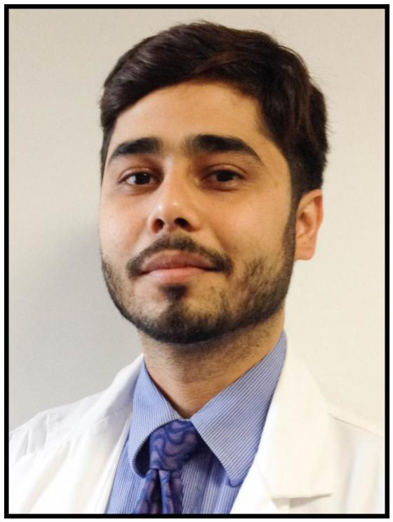

Adnan Khan is a graduate of the King Edward Medical Uni-versity, Lahore, Pakistan. He received his MBBS degree in 2007. After graduation, he worked two years in his home country as a Medical Officer. Dr. Khan came to the United States in 2011 and was hired by Dr. Bianca Weinstock Gutt-man to do MS research. He worked on numerous projects. He helped to develop a more personalized model for a pa-tient-tuned treatment selection for our MS patients as part of the DICER study. He also worked on determining risk factors that may predispose patients to MS via a study of bariatric surgery patients who have MS.

28

(1-2)

Introduction:

Stroke is one of the leading causes of mortality and morbidity in United States. Posterior circulation strokes account for approximately 20% -26%

of all ischemic strokes. Basilar artery occlusion (BAO) accounts for 8-11% of posterior circulation strokes (3-4). Basilar artery is the dominant artery of the posterior circulation and supplies very important structures including brain stem, occipital lobes, thalami and cerebellum. Depending on different de-grees of involvement of the brain stem, patients with acute BAO can present with symptoms vary from isolated cranial nerve palsies or hemiplegia to the locked in state or coma. Thus any ischemia to basilar artery territory can have devastating results. Despite recent advances in the treatment of acute ischemic stroke, the mortality or disability associated with basilar artery strokes still remains to be very high, almost 80 % (5-7).

Intravenous tissue-type plasminogen activator (IV rtPA) is the only FDA ap-proved pharmacological therapy for acute ischemic stroke, which is given within 4.5 hours of symptom onset. Randomized trials also have shown the safety and efficiency of Intra-arterial thrombolysis (IAT) either with intra-arterial tPA or with mechanical thrombectomy in the treatment of acute is-chemic stroke when given within the first 6 hours of symptom onset (8, 9). Due to very limited number of patients with acute BAO strokes in the pivotal IV rtPA and IAT trials and also very low incidence of acute BAO strokes com-pared to anterior circulation ones, only very limited retrospective data is available about the factors that might affect the outcome in the treatment of acute ischemic strokes patients who receive treatment whether with IV rtPA , Intra-arterial thrombolysis or combination of both.Case reports suggest that patients with BAO can recover from recanalization therapy even be-yond 8 hours after symptom onset (10). It still remains unclear whether the time window for recanalization therapy in stroke patients with acute BAO can be longer than patients with arterial occlusions in the anterior circulation and so far the frequent use of longer time window in daily practice is not supported by high quality scientific evidence. White matter, which is relatively more present in the brain stem than in other parts of the brain, might be more re-sistant to ischemia than other brain tissue. Furthermore, penumbral tissue might be preserved for a longer period of time as a result of better collat-erals in the posterior than in the anterior circulation. (11)

In this study, we are planning to evaluate the clinical and radiological fac-tors associated with outcome in the acute ischemic strokes caused by acute BAO who have received IV rtPA, IAT or combination of both in our compre-hensive stroke center from the beginning of January 2006 thru March 2015.
IRB :

Stroke Data base is already approved. Further updated approval is pending.
Disclosure and COI: None of the authors has anything to declare in relation to this study.

29

Born and raised in Toronto, Canada, Aurang-zeb relocated to Karachi, Pakistan at the age of 17, where he completed his pre-medical and medical school training. After complet-ing a preliminary year in internal medicine, he continued his post-graduate training in Neu-rology and is currently a PGY3. His research interests include cerebrovascular disease and epilepsy. Dr. Memon is one of the in-coming chief residents for the adult neurolo-gy residency program, after which he will pur-sue fellowship training in Epilepsy at Emory University in Atlanta, Georgia, USA.
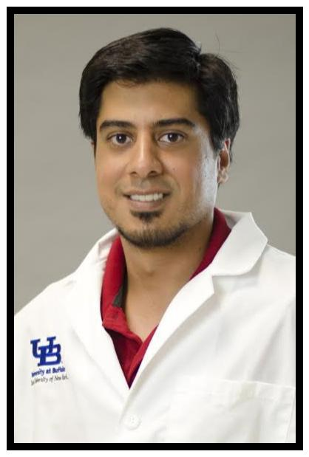

“Safety of Intravenous Thrombolysis for Acute Ischemic Stroke in Patients Taking Warfarin with Subtherapeutic INR”;

Aurangzeb Memon, PGY3, MBBS, Ashkan Mowla, MD State University of New York at Buffalo, Department of Neu-rology, USA

Introduction:

Current guidelines of the American Heart Association/American Stroke Association (AHA/ASA) allow use of intravenous rtPA in warfarin-treated acute ischemic stroke (AIS) patients who have an international normalized ratio (INR) of 1.7 or lower;.

However, concerns remain about the safety of using intravenous rtPA in patients taking warfarin with an elevated INR due to the fact that the value of 1.7 was not determined through randomized controlled trials and the available data are con-troversial.

Objectives:

Considering the high volume of patients receiving intravenous rtPA at our compre-hensive center, we are planning to evaluate the actual risk of major systemic bleeding or symptomatic intracranial bleeding with different INR levels in warfarin-treated AIS patients receiving intravenous rtPA in order to provide valuable data on this controversial topic.

Methods:

We plan to retrospectively look into our database of patients who received intrave-nous rtPA for AIS from January 2006 to March 2015 (over 750 patients). The list will be obtained from the Kaleida Health New York State GET WITH THE GUIDELINES da-tabase. We will identify a subgroup of patients who were taking Warfarin on the days prior to their AIS and had and elevated INR. We will determine the rate of ma-jor systemic bleeding or symptomatic intracranial bleeding after IV rtPA administra-tion in different INR levels in this subgroup of patients and will compare it with the other patients receiving IV rtPA.

Expected Results:

We believe that the result of our study might provide valuable information about the safety of intravenous rtPA in AIS patients taking warfarin with INRs less than 1.7. This may potentially play an important role in the revision of the guidelines about treatment of acute ischemic stroke.

30

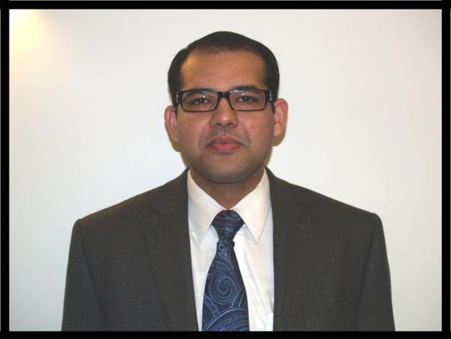
Dr. Mustafa earned his medical degree at Nishtar Medical College, Multan, Pakistan. After gradua-tion, he spent a few years doing clinical research at The University of Pennsylvania and Yale and then moved to Buffalo to work with the Stroke Neurology team at The Jacobs Neurologic Insti-tute. His primary research interest lies in cerebro-vascular diseases and he has published in peer-reviewed journals of neurology. After complet-ing a medicine internship from The State University of New York at Buffalo (SUNY Buffalo) currently, he is 3rd year neurology resident.

“Safety and Outcome of Intravenous Thrombolysis
for Ischemic Stroke in Patients over Age 80.”

Ghulam Mustafa, PGY 3, MBBS, Ashkan Mowla, MD

State University of New York at Buffalo;

School of Medicine and Biomedical Sciences,

Introduction:

Very limited data is available about the safety and efficacy of intravenous tissue-type plasminogen activator (IV rtPA) for acute ischemic stroke in patients aged above 80 years.

Objectives:

We are planning to evaluate the safety and outcome of IV rtPA for treatment of acute ischemic stroke in the very elderly (aged >80 years) and compare it with those aged <= 80 years in a retrospective study based on the data available from patients who received IV rtPA in our large volume comprehensive stroke center. Over 750 patients received IV rtPA in our stroke center since the beginning of 2006.

Methods:

We plan to retrospectively look into our database of patients who received IV rtPA for acute ischemic stroke from January 2006 to March 2015 (over 750 patients). The list will be obtained from the Kaleida Health New York State GET WITH THE GUIDELINES database. We will identify a subgroup of patients who were above age 80. We will determine the rate of symptomatic intracranial bleeding after IV rtPA administration in this age group and compared with those aged <= 80 years. We will also determine their outcome after IV rtPA with modified Rankin scale (mRS) at discharge.

Expected results:

Given our large volume, our study will be one of the largest studies on the safety and outcome of IV rtPA for acute ischemic strokes in patients aged above 80 years. The result of our study might be helpful in the revision of current guidelines on acute ischemic stroke treatment. The most recent guideline of American Stroke Association on “Early management of patients with acute ischemic stroke” consid-ers Age above 80 a relative contraindication for IV rtPA when given within 3 to 4.5 hours from symptom onset.

31

Graduation Dinner:

The Hotel Lafayette
391 Washington Street

Buffalo, NY 14203
June 12, 2015

6:00 pm
Cocktails

7:00 pm
Dinner

Adult Neurology Resident Program
Director’s Introductions and Comments:
Nicholas J. Silvestri, M.D.

Chairman’s Address:
Gil I. Wolfe, M.D., FAAN

Michael E. Cohen Research Day Awards
Presentation:
Michael E. Cohen, M.D.

Graduation Ceremony for Graduating Residents &
Fellows:

Nicholas J. Silvestri, M.D., Adult Neurology Resident
Program Director;

Thomas Langan, M.D., Child Neurology Resident Pro-

gram Director; Edward Fine, M.D., FAAN;
Clinical Neurophysiology

Fellowship Program Director and

Marilou Ching, M.D., MPH, Program Director, Vascular
Neurology Fellowship Program Director
Message by In-coming Chief Residents:

Drs. Aurangzeb Memon & Haris Kamal

Dessert

9:30 p.m. - End of Reception

32

